SSE2 Project Report
BoCoLa


Course: | SSE2 Spring 2010
Teacher: | Bent Brunn Kristensen
Faculty: | Faculty of Engineering at SDU
Due date: | Spring 2010

Group 1

Martin Moghadam
Kalle Grafström
Audrius Palisaitis
Robertas Jacauskas

Table of contents
1 - Introduction 3
2 – Language Definition 3
3 – Language Translation 3
4 – Runtime System Modification 3
5 – Example Experimentation 3
6 – Conclusion 3
7 – Appendix 3

1 - Introduction
In the course SSE2 we design, implement and experiment with a collaboration abstraction mechanism, BoCoLa, as a supplement to Java.

2 – Language Definition
In this section

3 – Language Translation
In this section

4 – Runtime System Modification
In this section

5 – Example Experimentation

BoCoLa program we write in to the text file, program syntax shown in table 5.1. There are two collaborations c1 and c2. Collaboration c1 synchronized, it was done by special keyword sync.
Table 5.1: Translation from BoCoLa to Java
Language | Syntax
BoCoLa | collaboration c1  between 0, 1, 2  [  sync(move by 1, work by 2);  move by 0;  ]  collaboration c2  between 3,4,5  [  move by 5;  work by 3;  move by 4;  ]
Java | Collaborations[No] = new Collaboration();  {  Collaborations[No-1].include(new BotMethod.botMove(),Bot.bots[1],new BotMethod.botWork(),Bot.bots[2]);  Collaborations[No-1].include(new BotMethod.botMove(),Bot.bots[0]);  }  Collaborations[No]=new Collaboration();  {  Collaborations[No-1].include(new BotMethod.botMove(),Bot.bots[5]);  Collaborations[No-1].include(new BotMethod.botWork(),Bot.bots[3]);  Collaborations[No-1].include(new BotMethod.botMove(),Bot.bots[4]);  }

Then BoCola program text were saved into the text file and than we executed our program. Our program produced java code which can be used in a BotsSystem program. Equivalent Java code of BoCola program shown in the table 5.1. As we see from results BoCoLa language more structured and better readable. To run BotsSystem and test it we need to copy java code in there, compile and execute. As result we can see our collaborations in the figure 5.1. Green collaboration between bot 1 and bot 2 are synchronized. Synchronized collaboration takes more time to execute because it has to wait until finish and then another can be executed. 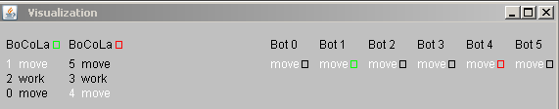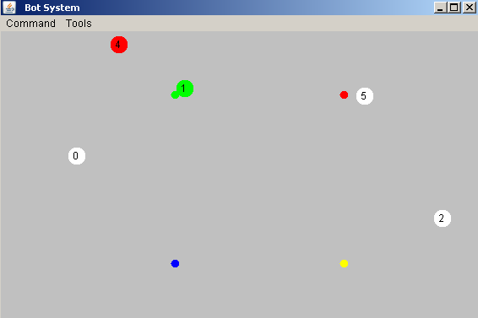
Figure 5.1: Bot System

In a conclusion we can say that if we use keyword sync then we lost time, because of longer execution. Always synchronized bot execution not allows other bots to execute. By this we guarantee right order of bots execution (move or/and work).

6 – Conclusion

7 – Appendix

The source code is included in the zip file and on the CD.

